Thermal Elastohydrodynamic Program

Carl-Magnus Everitt

Department of Solid Mechanics, Royal Institute of Technology – KTH, 100 44 Stockholm, Sweden

# Abstract

The program was developed in order to enable investigations of how surface roughness relates to rolling contact fatigue. The goal of the program was only to enable simulations of artificial asperities, indents and general rough surfaces, not to write a program that would be easy to use nor to be the fastest or the most robust one. However, since the code is capable of simulating time dependent thermal elastohydrodynamic contacts including different surface roughness’s it might be of use for others. The code is therefore distributed as an open source code free to use for anyone. The author does not take any responsibility for the code. Some example files are included in order for future uses to get started easier and to show the validity of the code. Figures showing the validity of the code are also presented in this manuscript.

# Keywords

Numerical program; Contact Mechanics; Rough Surface; Thermal Elastohydrodynamic Lubrication.

# Highlights

* A numerical program for simulations of rough surfaces in THEL contacts
* A short description of the layout of the code
* Input files for validation of the code
* Figures showing the accuracy of the code

1. Introduction

This document aims to help clarify a few things about the code. It is however not written to be a complete user guideline. The numerical code is based upon the code written by P. Huang [1]. A lot of the basic framework along with some names of parameters and subroutines are kept from P. Huang’s version. The reads is referred to his book for a deeper understanding of the basics of the code structure. The code is written in Fortran 90 and has been complied without problems on both Windows and Linux systems. It can run either on a single core or be parallelized on multiple cores. Due to the many do-loops inside the program it is recommended to use at least 8 cores. Since little time was spent on achieving a fast code, the simulations can take a while. The number of nodes and instances of metal contact drastically increases the simulation time. The simulation of a rough, shot peened, surface causing metal contact presented in chapter 4.7 took 46 hours to run using 8 cores. The resolution was set to 257 · 161 nodes and a total of 377 time steps were computed. With lower surface roughness, so that no metal contact is reached, the simulations could finish within less than 24 hours.

The main goal of the program is to find the pressure distribution. This is based upon an implicit iteration scheme set up to minimize the residual of the Reynolds equation. The material parameters of the lubricant and the elastic deformations has to be included in the iterations in order to achieve the pressure distribution. If wanted, the temperature fields can also be calculated. These are based on an explicit iteration scheme based upon the energy equation. The deformation can either be evaluated based on the summation of contributions from different point loads [2] or with fast flourier transforms [3].

The code starts by searching for the time independent solution to the isothermal problem on a course grid. The grid is thereafter refined until and the calculations of the temperature filed is added. The time dependency is slowly introduced after a solution is obtained on the fines grid. The time dependent simulations run for the whole time needed for the surface irregularities to pass the contact.

The changes in viscosity and density due to the pressure and temperature is modelled in several different ways. Which equation and which formulation that is desired is controlled with the parameters in the input file. Almost all essential parameters can be defined in the input file which should be a comma separated values, csv, file. The parameters are read based upon their position in the input file. The first line states the names on the input variables to make it easier for the user to know which parameter is positioned where. The next line contains the values and the third line is left blank in order to obtain a better overview. This structure is repeated so the values are stated on every third line.

The program prints the pressure, the film thickness, the shear tractions and the temperature of the lubricant for each time step. This data could then be post-processed either in a FE program or analysed with analytical equations in order to obtain the stress fields in the solids.

1. Code layout

The numerical program is divided into subroutines which are stored in separate files with the same name as the subroutine. The figure below illustrates the layout of the subroutines with arrows indicating which subroutine is called by which. Some arguments are passes via the call statement for the subroutine but the majority of the generated data is stored inside common blocks.

The last part of each simulation step is to print out the data into different files. Thus not storing more and more data inside the code. The pressure is for example printed out to the file called PRESSURE.dat. The data is just added after any previous data from any previous steps solved by the program.

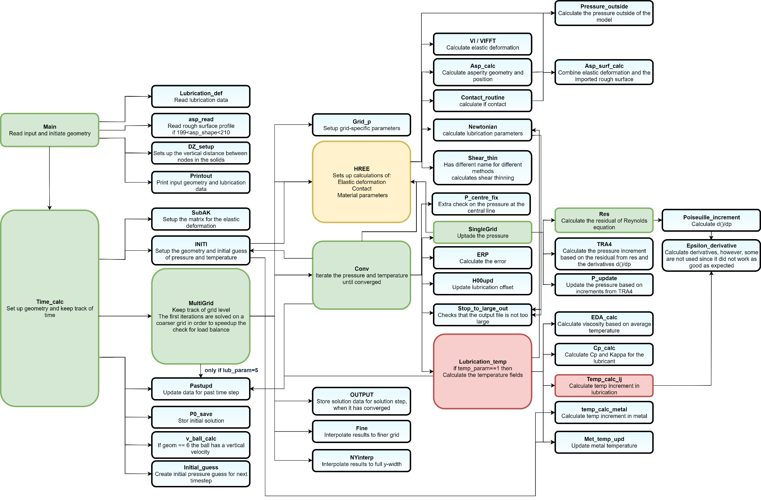

1. The input file

This section describes the parameters of the input file.

* 1. The first three lines

These lines controls the general setup of the program

The parameter **meth** stands for which method to use for the pressure derivatives. The range is 1-3 where 1 = 1st order backspace method, 2 = 2nd order backspace and 3 = central space. The option 2 is recommended and the option 3 is not recommended since it’s not working correctly.

The parameter **Tmeth** controls the formulation of the time derivatives. The option Tmeth = 4 is recommended.

The parameter **Geom** controls which type of geometry that should be analysed. 1 = Cylindrical contact, 2 = Spherical contact, 3 = Elliptical contact, 4-5 = Cylindrical contact with different input settings and 6 = Setup to simulate experiments by Höglund *et al.*

The parameter **Aspchape** controls the shape of the surface roughness. Lower numbers are for different analytical shapes while 200-209 states the the program should read the surface defined by the file Fortran_surface.csv. See the Asp_Calc subroutine for details.

The parameter **Contact_alg** defines the contact routine used. The option 1 is recommended here.

The parameter **P_ave_param** controls how the pressure should be stabilized in the transverse direction for cylindrical simulations. The option P_ave_param = 1 is suggested.

The parameter **Shift_y** defines how the rough surface read from the file Fortran_surface.csv should be positioned in the transverse direction. The parameter states how many nodes the surface should be moved in the transverse direction.

The parameter **Multi_grid_param** controls is the solution should be obtained on a courser grid first. The value 1 is recommended since it generally goes faster to find a solution if a courser grid is used in the beginning. The value 0 could be used to directly start with the fines grid.

* 1. The second set of lines

These lines controls the grid size and the number of time steps.

The parameter **NX** controls the number of nodes in the rolling direction, x-direction. This number will be change slightly in order to obtain a grid for the coarsest grid as well. A number between 100-300 is suggested.

The parameter **NY** controls the number of nodes in the transverse direction, y-direction. This number will be change slightly in order to obtain a grid for the coarsest grid as well. A number between 50 and 300 is suggested. It should be close to NX if simulating a spherical contact. The spatial distance between the nodes is the same in the rolling and the transverse direction.

The parameter **X0** defines the inlet of the simulation.

The parameter **F** defines how fast the surface irregularities should move. F=1 states that the irregularities should move one node at each time step.

The parameter **DZ_method** defines which vertical spacing method to use for the nodes used in the temperature calculations of the metals. The horizontal spacing of the thermal nodes in the solids is twice the spacing of the nodes used for the pressure calculations.

The parameter **Dw_Meth** defines which method to be used for finding the lubrication offset H00. See more in the subroutine file H00upd.f90.

* 1. The third set of lines

These lines controls the geometry of the problem.

The parameter **RX** defines the radius in the rolling direction.

The parameter **W0** controls the normal load to the contact. The value is scaled with 105 when simulating a cylindrical contact.

The parameter **Ua** defines the speed of the surface with the asperity.

The parameter **Ub** defines the speed of the counter surface.

The parameter **Lub_param** defines which set of equations to be used to describe the lubricant.

The parameter **Shear_thin** defines which set of shear thinning equations to use. These are not working properly and thus the value 0 is recomended.

The parameter **temp** defines if the temperature fields should be solved for or not.

The parameter **Solid_mat** defines material equations to be used for the solid materials. Only relevant

* 1. The fourth set of lines

These lines controls the load and radius for Geom = 3-5. See the Main file for more information.

* 1. The fifth set of lines

These lines controls the size of the analytical surface roughness

The parameter **Asph_real** defines the height in micro meters of the initial defect.

The parameter **Aspw_real** defines the width in micro meters of the initial defect.

The parameter **Asph_real2** defines the height in micro meters of the second defect.

The parameter **Aspw_real2** defines the width in micro meters of the second defect.

The parameter **Asph_ratio** defines the ratio between the width in the rolling and the transverse direction. If the ratio is 1 the defects are axisymmetric.

The parameter **Hminimum** defines the minimum film thickness allowed in the simulations. If the film thickness decreases below this point metal to metal contact is defined to occur. This numer is scaled with 10-6. A higher number will yield a more stable solution. Suggested is to use a number between 5 and 100.

The parameter **Surf_scale** is used when an external surface structure is read from the file Fortran_surface.csv. The imported structure is scaled with the value defined by this parameter.

* 1. The sixth set of lines

These lines controls the size of the analytical surface roughness

The parameter **Elast1** defines the elastic modulus of the first body.

The parameter **Elast2** defines the elastic body of the second body.

The parameter **EE** defines the equivalent elastic modulus. If this is zero, the equivalent elastic modulus will be calculated from Ealst1 and Elast2. The Passion’s ratio is set in the code to be 0.3.

* 1. The seventh set of lines

These lines controls the number of iterations and the convergence criteria.

The parameter **MK_stat** defines the maximum number of iterations to be used for the time-independent iterations. Somewhere around 400 is suggested.

The parameter **MK_time** defines the maximum number of iterations to be used for the time-dependent iterations. Somewhere around 200 is suggested.

The parameter **ER_stat** defines the convergence criteria for the time-independent iterations. Somewhere around 1 is suggested.

The parameter **ER_time** defines the convergence criteria for the time-dependent iterations. Somewhere around 1 is suggested.

The parameter **KK** defines number of internal pressure iterations to be performed within each global pressure iteration for the time time-independent steps. Somewhere around 5-10 is suggested.

The parameter **KK_time** defines number of internal pressure iterations to be performed within each global pressure iteration for the time time-dependent steps. Somewhere around 5-10 is suggested. A lower number might speed up the solution but might be less stable.

* 1. The eigth set of lines

These lines controls the value of the relaxation parameter used in the pressure updates

The parameter **C_meth** defines the general method for defining the value of the relaxation parameter C1. See the P_update subroutine for more info.

The parameter **C_loc** is a parameter controlling the value of the relaxation parameter c1. See the P_update subroutine for more info. Suggested value is around 0.1.

The parameter **C_glob** is a parameter controlling the value of the relaxation parameter c1. See the P_update subroutine for more info. Suggested value is around 0.05.

The parameter **C_min** is a parameter controlling the value of the relaxation parameter c1. See the P_update subroutine for more info. Suggested value is around 0.05.

The parameter **C_max** is a parameter controlling the value of the relaxation parameter c1. See the P_update subroutine for more info. Suggested value is around 0.5.

The parameter **Umax_P** controles the maximum allowed speed difference in the rolling direction for the temperature calculations. The value 1 is suggested because that limits the velocity cange to the mean velocity um. See calculation in Lubrication_temp.

* 1. The ninth set of lines

These lines controls the lubrication offset H00 and if shear bands are going to be assumed when calculating the heat flux to the solid bodies.

The parameter **H00** defines initial lubrication offset. The closer this solution is to the real solution the faster the convergence. It is better to start off the high than too low. A value around -1 I suggested.

The parameter **HM0f** contorles the increments of H00 in the subroutine H00upd. A value of 0.5 is suggested.

The parameter **H00_method** defines which method to be used for calculating the initial value of H00. See the Main file for more info.

The parameter **temp_r** defines the initial temperature increase. However, its overwritten in the Initi subroutine.

The parameter **Shear_band** defines if the temperature calculation should use shear bands for estimating how much energy is transferred down to the metal. See Temp_calc_metal for more info.

The parameter **Shear_xi** defines the location of the shear bands. See Temp_calc_metal for more info.

* 1. The tenth set of lines

Here basic information of the lubricant is defined

The parameter **Temp** defines the inlet temperature of the lubricant and the metals.

The parameter **Z** defines the exponent in the Roeland’s pressure viscosity equation. Not used by all lubrication models controlled by the Lub_param parameter. See the Lubrication_def subroutine for more info.

The parameter **EDA0** defines the initial viscosity of the lubricant.

The parameter **Pref** defines the reference pressure. The value is multiplied with 108.

The parameter **alpha** defines the viscosity-pressure exponent for Barus equation. The value is multiplied with 10-8.

The parameter **RA1** is a parameter in the density-pressure equation. The value is multiplied with 10-9. Suggested is somewhere around 0.7.

The parameter **RA2** is a parameter in the density-pressure equation. The value is multiplied with 10-9. Suggested value is somewhere around 2.5.

* 1. The following lines

These lines compliments the tenth line with more parameters for the lubricant. These are read a bit different depending on which lubrication model, lub_param, that is used. Se the subroutine Lubrication_def for more info.

* 1. The second last input line

This line controls if the full data is going to be collected or not and if the simulation starts from the beginning or in the middle. If it starts in the middle it needs data from the previous time steps. This option was developed in order to enable faster evaluation of code updates.

The parameter **Collect_full_data** defines if all the data should be printed out. Since there are many layers of metal nodes this will generate quite a lot of data. Therefore the common option is only to print out key results as the pressure, film thickness and the temperature of the lubricant.

The parameter **Single_step_only** defines if the simulation should only performed on time step.

The parameter **selected_step** defines which single step to be analysed.

* 1. The last input line

This line controls how many cores to be used in the simulation.

The parameter **Use_multiple_cores** defines the code should be executed on a single core or in parallel on multiple cores. The code scales well up to at least 8 cores.

The parameter **cores** defines the number of cores to be used.

1. Validation

A number of input files are included to enable users to check the validity of the code. The accuracy of the code is presented in figures and value comparison. The references data in the figures was manually extracted from the cited articles and may thus not be exact. Matlab programs for are included among the supplementary files which evaluates the results and compares it to the relevant data of the literature. The validity of the code could also be checked against other results in the literature.

* 1. Line contact with a furrow

The input data is presented in Table 1. The result of previous simulations with this input file is presented in Fig. 1. The comparison with the results from the literature shows great correlation with the time independent case. For the time dependent case the current code generates a slightly higher pressure wave than the reference case of the literature.

Table 1. Input parameter for validation against a line contact with a line furrow

|  |  |  |  |  |  |  |  |
| --- | --- | --- | --- | --- | --- | --- | --- |
| **meth** | **Tmeth** | **Geom** | **Aspchape** | **Contact alg** | **p_ave_param** | **shift_y** |  |
| 2 | 4 | 1 | 1 | 1 | 1 | 35 |  |
|  |  |  |  |  |  |  |  |
| **NX,** | **NY,** | **X0,** | **XE,** | **F Grid** |  |  |  |
| 260 | 70 | -2.0 | 1.5 | 2 | 1 |  |  |
|  |  |  |  |  |  |  |  |
| **RX,** | **W0** | **Ua,** | **Ub,** | **lub_param** | **Shear_thin** | **temp** | **solid_mat** |
| 0.0141 | 15.708 | 0.485 | 1.455 | 1 | 0 | 0 | 1 |
|  |  |  |  |  |  |  |  |
| **B/B_ref/PH_new*1e9** | **by/-/-** | **Ph*1e9/=/=** | **Ry** |  |  |  |  |
| 0.0068 | 10.775 | 7 | 7 |  |  |  |  |
|  |  |  |  |  |  |  |  |
| **Asph_real [um]** | **aspw_real [um]** | **Asph_real2 [um]** | **aspw_real2 [um]** | **Asp_ratio W_X/W_Y** | **Hminimum*1E-6 [-]** | |  |
| 2 | 500 | 0.11 | 50 | 1 | 5 |  |  |
|  |  |  |  |  |  |  |  |
| **Elast1 [GPa]** | **Elast2 [GPa]** | **EE [GPa]** |  |  |  |  |  |
| 206 | 206 | 226 | <- If zero, read E1 and E2 | | |  |  |
|  |  |  |  |  |  |  |  |
| **MK_stat** | **MK_time** | **ER_stat** | **ER_time** | **KK** | **KK_time** | **Dw_meth** |  |
| 600 | 400 | 0.1 | 0.1 | 10 | 10 | 1 |  |
|  |  |  |  |  |  |  |  |
| **C_meth** | **C_loc** | **C_glob** | **C_min** | **C_max** |  |  |  |
| 8 | 0.1 | 0.05 | 0.05 | 0.5 |  |  |  |
|  |  |  |  |  |  |  |  |
| **H00,** | **HM0f** |  |  |  |  |  |  |
| -1.569 | 0.8 | 0 | 130 |  |  |  |  |
|  |  |  |  |  |  |  |  |
| **Temp=Ta degC** | **Z** | **EDA0** | **Pref *1e8** | **alpha*1E-8** | **RA1*1E-9** | **RA2*1E-9** |  |
| 90 | 0.68 | 0.04 | 1.98 | 2.2 | 0.69 | 2.55 |  |
|  |  |  |  |  |  |  |  |
| **kH*1E-6** | **xH*1E-9** | **lH*1E-9** | **gH*1E-9** |  |  |  |  |
| 63.15 | 5.1 | 1.68 | 2.266 |  |  |  |  |
|  |  |  |  |  |  |  |  |
| **EpsT0** | **S0** | **RL_G0** | **Dz** | **Cz** |  |  |  |
| 0.00068 | 1.25 | 4.57 | 0.5 | -0.071 |  |  |  |
|  |  |  |  |  |  |  |  |
| **Tg0,** | **YA1,** | **YA2,** | **YB1,** | **YB2on** |  |  |  |
| 0 | 0 | 0 | 0 | 10 | 0.075 | 5 |  |
|  |  |  |  |  |  |  |  |
| **YC1,** | **YC2,** | **Yedag,** | **Yalfag,** |  |  |  |  |
| 16.01 | 20.69 | 1 | 3.814697 |  |  |  |  |
|  |  |  |  |  |  |  |  |
| **tauc_real,** | **tauS,** | **taua2,** | **xilim** | **xi_param** |  |  |  |
| 25 | 0.4 | 0 | 0.8 | 1 |  |  |  |
|  |  |  |  |  |  |  |  |
| **L_n** | **L_G*1e4** | **L_h_limit*1e-9 [m]** | **L_iter** | **L_stab** | **shear max** | **shear min** | **temp max** |
| 0.74 | 3.1 | 1 | 20 | 1 |  |  |  |
|  |  |  |  |  |  |  |  |
| **collect_full_data** | **single_step_only** | **selected_step** | |  |  |  |  |
| .false. | .false. | 423 |  |  |  |  |  |
|  |  |  |  |  |  |  |  |
| **use_multiple_cores** | **cores** |  |  |  |  |  |  |
| .true. | 8 |  |  |  |  |  |  |

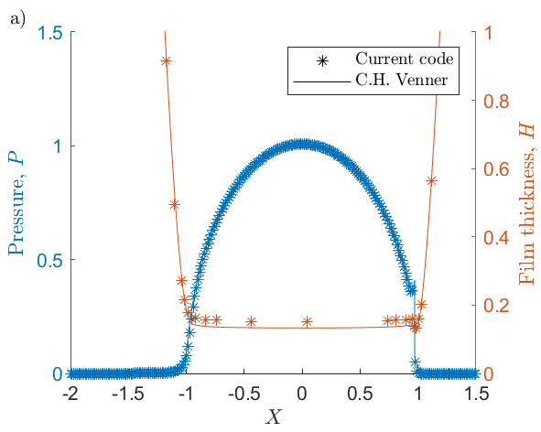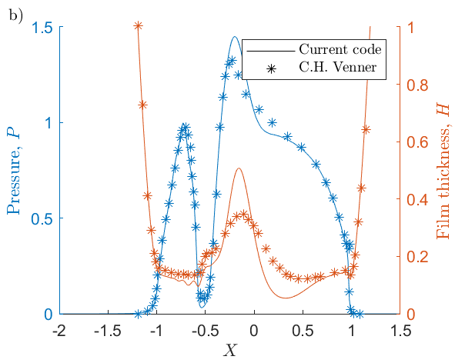

Fig. 1 Comparison of pressure and film thickness results between the current code and results from the literature [2]. a) Time independent case with smooth surfaces and b) time dependent case when the furrow is at X=-0.5.

* 1. Film thickness for the ball on disk setup

The ball on disk setup defined in Table 2 can be sued to validate the minimum and central film thickness by comparing with results in the literature [3]. The current code gave a minimum film thickness of 75.7·10-4 while the literature [3] states 75·10-4. For the central fil thickness the current code gave 23.0·10-3 while the literature [3] states 22.5·10-3 for the resolution of 100 nodes per contact half width. This agreement is very good.

Table 2. Input data for validation of film thickness of a ball on disk setup

|  |  |  |  |  |  |  |  |
| --- | --- | --- | --- | --- | --- | --- | --- |
| **meth** | **Tmeth** | **Geom** | **Aspchape** | **Contact alg** | |  |  |
| 2 | 4 | 2 | 0 | 1 | 1 | 35 | 1 |
|  |  |  |  |  |  |  |  |
| **NX,** | **NY,** | **X0,** | **XE,** | **F Grid** | **DZ_method** | **Dw_meth** | |
| 400 | 400 | -2.5 | 1.5 | 2 | 1 | 1 |  |
|  |  |  |  |  |  |  |  |
| **RX,** | **W0*(E5 if Cylinder)** | **Ua,** | **Ub,** | **lub_param** | **Shear_thin** | **temp** | **solid_mat** |
| 0.00635 | 19.8 | 0.21 | 0.21 | 3 | 0 | 0 | 1 |
|  |  |  |  |  |  |  |  |
| **B/B_ref/PH_new*1e9** | **by/-/-** | **Ph*1e9/=/=** | **Ry** |  |  |  |  |
| 0.0068 | 10.775 | 7 | 7 |  |  |  |  |
|  |  |  |  |  |  |  |  |
| **Asph_real [um]** | **aspw_real [um]** | **Asph_real2 [um]** | **aspw_real2 [um]** | **Asp_ratio W_X/W_Y** | **Hminimum*1E-6 [-]** | |  |
| 0.2 | 128.9 | 0.2 | 129 | 1 | 5 |  |  |
|  |  |  |  |  |  |  |  |
| **Elast1 [GPa]** | **Elast2 [GPa]** | **EE [GPa]** |  |  |  |  |  |
| 206 | 206 | 227.3 | <- If zero, read E1 and E2 | | |  |  |
|  |  |  |  |  |  |  |  |
| **MK_stat** | **MK_time** | **ER_stat** | **ER_time** | **KK** | **KK_time** | **Dw_meth** |  |
| 400 | 200 | 0.05 | 0.05 | 5 | 5 | 1 |  |
|  |  |  |  |  |  |  |  |
| **C_meth** | **C_loc** | **C_glob** | **C_min** | **C_max** |  |  |  |
| 8 | 0.1 | 0.05 | 0.05 | 0.5 |  |  |  |
|  |  |  |  |  |  |  |  |
| **H00,** | **HM0f** |  |  |  |  |  |  |
| -0.98 | 0.5 | 0 | 130 |  |  |  |  |
|  |  |  |  |  |  |  |  |
| **Temp=Ta degC** | **Z** | **EDA0** | **Pref *1e8** | **alpha*1E-8** | **RA1*1E-9** | **RA2*1E-9** |  |
| 90 | 0.68 | 0.0096 | 1.98 | 1.763 | 0.69 | 2.55 |  |
|  |  |  |  |  |  |  |  |
| **kH*1E-6** | **xH*1E-9** | **lH*1E-9** | **gH*1E-9** |  |  |  |  |
| 63.15 | 5.1 | 1.68 | 2.266 |  |  |  |  |
|  |  |  |  |  |  |  |  |
| **EpsT0** | **S0** | **RL_G0** | **Dz** | **Cz** |  |  |  |
| 0.00068 | 1.25 | 4.57 | 0.5 | -0.071 |  |  |  |
|  |  |  |  |  |  |  |  |
| **Tg0,** | **YA1,** | **YA2,** | **YB1,** | **YB2on** |  |  |  |
| 0 | 0 | 0 | 0 | 10 | 0.075 | 5 |  |
|  |  |  |  |  |  |  |  |
| **YC1,** | **YC2,** | **Yedag,** | **Yalfag,** |  |  |  |  |
| 16.01 | 20.69 | 1 | 3.814697 |  |  |  |  |
|  |  |  |  |  |  |  |  |
| **tauc_real,** | **tauS,** | **taua2,** | **xilim** | **xi_param** |  |  |  |
| 25 | 0.4 | 0 | 0.8 | 1 |  |  |  |
|  |  |  |  |  |  |  |  |
| **L_n** | **L_G*1e4** | **L_h_limit*1e-9 [m]** | **L_iter** | **L_stab** | **shear max** | **shear min** | **temp max** |
| 0.74 | 3.1 | 1 | 20 | 1 |  |  |  |
|  |  |  |  |  |  |  |  |
| **collect_full_data** | **single_step_only** | **selected_step** | |  |  |  |  |
| .false. | .false. | 423 |  |  |  |  |  |
|  |  |  |  |  |  |  |  |
| **use_multiple_cores** | **cores** |  |  |  |  |  |  |
| .true. | 8 |  |  |  |  |  |  |

* 1. Line ridge on a ball in pure rolling

The input data for simulation a line ridge on a ball in pure rolling is presented in Table 3. The results are presented in Fig. 2 which are compared with data from the literature [3] [4]. Since the data was easier to extract from [3] than from [4] it was used for the case when the ridge was at *X*=0.0. The agreement is satisfactory for all cases.

Table 3. Input parameters for ball on disk setup with a line ridge

|  |  |  |  |  |  |  |  |
| --- | --- | --- | --- | --- | --- | --- | --- |
| **meth** | **Tmeth** | **Geom** | **Aspchape** | **Contact alg** | |  |  |
| 2 | 4 | 2 | 1 | 1 | 1 | 35 |  |
|  |  |  |  |  |  |  |  |
| **NX,** | **NY,** | **X0,** | **XE,** | **F Grid** |  |  |  |
| 268 | 268 | -2.5 | 1.5 | 0.5 | 1 |  |  |
|  |  |  |  |  |  |  |  |
| **RX,** | **W0*(E5 if Cylinder)** | **Ua,** | **Ub,** | **lub_param** | **Shear_thin** | **temp** | **solid_mat** |
| 0.0127 | 38.3509 | 0.01075 | 0.01075 | 1 | 0 | 0 | 1 |
|  |  |  |  |  |  |  |  |
| **B/B_ref/PH_new*1e9** | **by/-/-** | **Ph*1e9/=/=** | **Ry** |  |  |  |  |
| 0.0068 | 10.775 | 7 | 7 |  |  |  |  |
|  |  |  |  |  |  |  |  |
| **Asph_real [um]** | **aspw_real [um]** | **Asph_real2 [um]** | **aspw_real2 [um]** | **Asp_ratio W_X/W_Y** | **Hminimum*1E-6 [-]** | |  |
| -0.2 | 128.9 | 0.2 | 129 | 1 | 5 |  |  |
|  |  |  |  |  |  |  |  |
| **Elast1 [GPa]** | **Elast2 [GPa]** | **EE [GPa]** |  |  |  |  |  |
| 206 | 206 | 117 | <- If zero, read E1 and E2 | | |  |  |
|  |  |  |  |  |  |  |  |
| **MK_stat** | **MK_time** | **ER_stat** | **ER_time** | **KK** | **KK_time** | **Dw_meth** |  |
| 400 | 200 | 0.5 | 0.5 | 5 | 5 | 1 |  |
|  |  |  |  |  |  |  |  |
| **C_meth** | **C_loc** | **C_glob** | **C_min** | **C_max** |  |  |  |
| 8 | 0.1 | 0.05 | 0.05 | 0.5 |  |  |  |
|  |  |  |  |  |  |  |  |
| **H00,** | **HM0f** |  |  |  |  |  |  |
| -0.9479 | 0.5 | 0 | 130 |  |  |  |  |
|  |  |  |  |  |  |  |  |
| **Temp=Ta degC** | **Z** | **EDA0** | **Pref *1e8** | **alpha*1E-8** | **RA1*1E-9** | **RA2*1E-9** |  |
| 90 | 0.68 | 1.22 | 1.98 | 2.2 | 0.69 | 2.55 |  |
|  |  |  |  |  |  |  |  |
| **kH*1E-6** | **xH*1E-9** | **lH*1E-9** | **gH*1E-9** |  |  |  |  |
| 63.15 | 5.1 | 1.68 | 2.266 |  |  |  |  |
|  |  |  |  |  |  |  |  |
| **EpsT0** | **S0** | **RL_G0** | **Dz** | **Cz** |  |  |  |
| 0.00068 | 1.25 | 4.57 | 0.5 | -0.071 |  |  |  |
|  |  |  |  |  |  |  |  |
| **Tg0,** | **YA1,** | **YA2,** | **YB1,** | **YB2on** |  |  |  |
| 0 | 0 | 0 | 0 | 10 | 0.075 | 5 |  |
|  |  |  |  |  |  |  |  |
| **YC1,** | **YC2,** | **Yedag,** | **Yalfag,** |  |  |  |  |
| 16.01 | 20.69 | 1 | 3.814697 |  |  |  |  |
|  |  |  |  |  |  |  |  |
| **tauc_real,** | **tauS,** | **taua2,** | **xilim** | **xi_param** |  |  |  |
| 25 | 0.4 | 0 | 0.8 | 1 |  |  |  |
|  |  |  |  |  |  |  |  |
| **L_n** | **L_G*1e4** | **L_h_limit*1e-9 [m]** | **L_iter** | **L_stab** | **shear max** | **shear min** | **temp max** |
| 0.74 | 3.1 | 1 | 20 | 1 |  |  |  |
|  |  |  |  |  |  |  |  |
| **collect_full_data** | **single_step_only** | **selected_step** | |  |  |  |  |
| .false. | .false. | 423 |  |  |  |  |  |
|  |  |  |  |  |  |  |  |
| **use_multiple_cores** | **cores** |  |  |  |  |  |  |
| .true. | 8 |  |  |  |  |  |  |

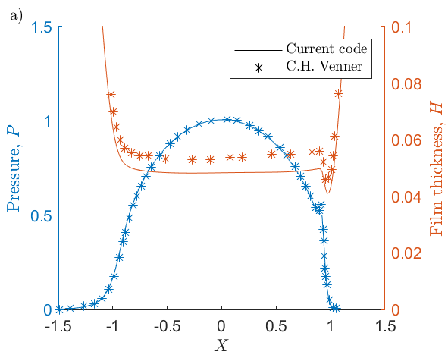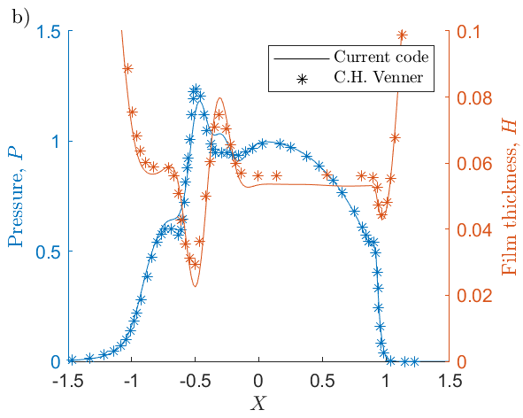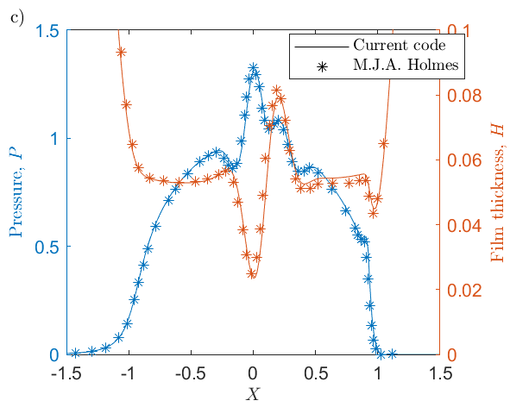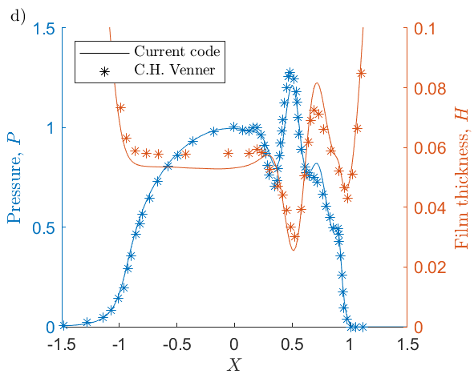

Fig. 2. Results of a line ridge on a ball in pure rolling for different positions of the ridge. a) Time independent case, b) time dependent case with the ridge at X=-0.5, c) time dependent case with the ridge at X=0.0 and d) time dependent case with the ridge at X=0.5.

* 1. Line ridge on a ball with slip

The input data for simulation a line ridge on a ball in pure rolling is presented in Table 4. The results are presented in Fig. 3 which are compared with data from the literature [4]. Since the ridge moves slower than the lubricant the ridge is separated from its complementary effect on the lubricant. The complementary effect moves twice as fast as the ridge and is thus at the outlet in Fig. 3c. Good agreement with the literature was obtained.

Table 4. Input data for simulations of a line ridge on a ball on disk setup with slip

|  |  |  |  |  |  |  |  |
| --- | --- | --- | --- | --- | --- | --- | --- |
| **meth** | **Tmeth** | **Geom** | **Aspchape** | **Contact alg** | |  |  |
| 2 | 4 | 2 | 1 | 1 | 1 | 35 | 1 |
|  |  |  |  |  |  |  |  |
| **NX,** | **NY,** | **X0,** | **XE,** | **F Grid** | **DZ_method** | **Dw_meth** | |
| 268 | 268 | -2.5 | 1.5 | 0.5 | 1 | 1 |  |
|  |  |  |  |  |  |  |  |
| **RX,** | **W0*(E5 if Cylinder)** | **Ua,** | **Ub,** | **lub_param** | **Shear_thin** | **temp** | **solid_mat** |
| 0.0127 | 38.3509 | 0.005375 | 0.016125 | 1 | 0 | 0 | 1 |
|  |  |  |  |  |  |  |  |
| **B/B_ref/PH_new*1e9** | **by/-/-** | **Ph*1e9/=/=** | **Ry** |  |  |  |  |
| 0.0068 | 10.775 | 7 | 7 |  |  |  |  |
|  |  |  |  |  |  |  |  |
| **Asph_real [um]** | **aspw_real [um]** | **Asph_real2 [um]** | **aspw_real2 [um]** | **Asp_ratio W_X/W_Y** | **Hminimum*1E-6 [-]** | |  |
| -0.2 | 128.9 | 0.2 | 129 | 1 | 5 |  |  |
|  |  |  |  |  |  |  |  |
| **Elast1 [GPa]** | **Elast2 [GPa]** | **EE [GPa]** |  |  |  |  |  |
| 206 | 206 | 117 | <- If zero, read E1 and E2 | | |  |  |
|  |  |  |  |  |  |  |  |
| **MK_stat** | **MK_time** | **ER_stat** | **ER_time** | **KK** | **KK_time** | **Dw_meth** |  |
| 400 | 200 | 0.5 | 0.05 | 5 | 5 | 1 |  |
|  |  |  |  |  |  |  |  |
| **C_meth** | **C_loc** | **C_glob** | **C_min** | **C_max** |  |  |  |
| 8 | 0.1 | 0.05 | 0.05 | 0.5 |  |  |  |
|  |  |  |  |  |  |  |  |
| **H00,** | **HM0f** |  |  |  |  |  |  |
| -0.9479 | 0.5 | 0 | 130 |  |  |  |  |
|  |  |  |  |  |  |  |  |
| **Temp=Ta degC** | **Z** | **EDA0** | **Pref *1e8** | **alpha*1E-8** | **RA1*1E-9** | **RA2*1E-9** |  |
| 90 | 0.68 | 1.22 | 1.98 | 2.2 | 0.69 | 2.55 |  |
|  |  |  |  |  |  |  |  |
| **kH*1E-6** | **xH*1E-9** | **lH*1E-9** | **gH*1E-9** |  |  |  |  |
| 63.15 | 5.1 | 1.68 | 2.266 |  |  |  |  |
|  |  |  |  |  |  |  |  |
| **EpsT0** | **S0** | **RL_G0** | **Dz** | **Cz** |  |  |  |
| 0.00068 | 1.25 | 4.57 | 0.5 | -0.071 |  |  |  |
|  |  |  |  |  |  |  |  |
| **Tg0,** | **YA1,** | **YA2,** | **YB1,** | **YB2on** |  |  |  |
| 0 | 0 | 0 | 0 | 10 | 0.075 | 5 |  |
|  |  |  |  |  |  |  |  |
| **YC1,** | **YC2,** | **Yedag,** | **Yalfag,** |  |  |  |  |
| 16.01 | 20.69 | 1 | 3.814697 |  |  |  |  |
|  |  |  |  |  |  |  |  |
| **tauc_real,** | **tauS,** | **taua2,** | **xilim** | **xi_param** |  |  |  |
| 25 | 0.4 | 0 | 0.8 | 1 |  |  |  |
|  |  |  |  |  |  |  |  |
| **L_n** | **L_G*1e4** | **L_h_limit*1e-9 [m]** | **L_iter** | **L_stab** | **shear max** | **shear min** | **temp max** |
| 0.74 | 3.1 | 1 | 20 | 1 |  |  |  |
|  |  |  |  |  |  |  |  |
| **collect_full_data** | **single_step_only** | **selected_step** | |  |  |  |  |
| .false. | .false. | 423 |  |  |  |  |  |
|  |  |  |  |  |  |  |  |
| **use_multiple_cores** | **cores** |  |  |  |  |  |  |
| .true. | 8 |  |  |  |  |  |  |

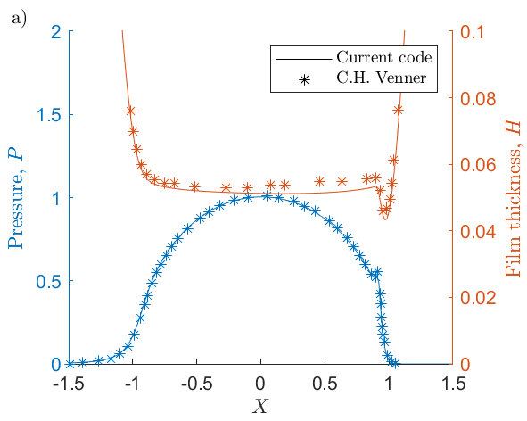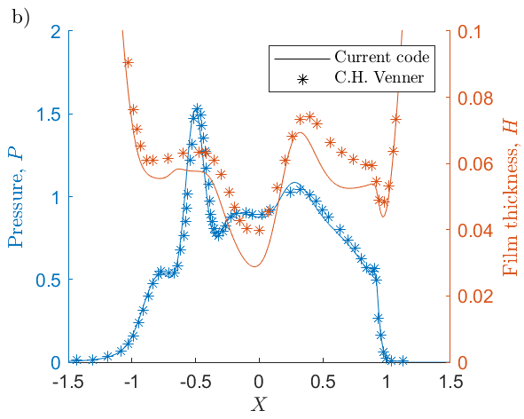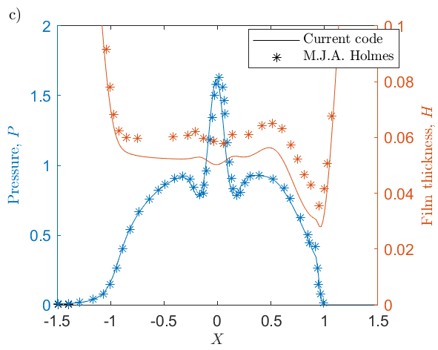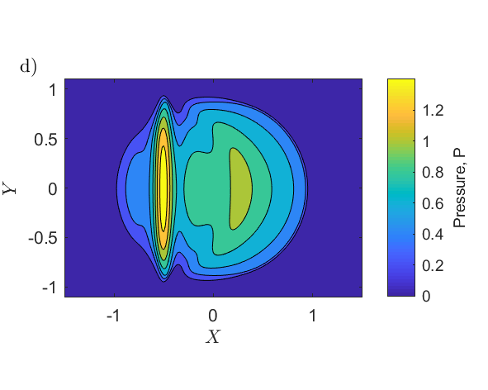

Fig. 3. Results of a line ridge on a ball in a rolling sliding contact. a) Time independent case, b) time dependent case with the ridge at X=-0.5, c) time dependent case with the ridge at X=0.0 and d) contour plot of pressure when the ridge at X=-0.5 and.

* 1. Point asperity in a sliding line contact including the temperature fields

This section presents the input files to use in order to replicate previous results generated by the code which have been published previously [7]. The input parameters are presented in Table 5. The results generate are presented in Fig. 4. The thick solid lines represents the time independent case. The time dependent results are visualized with dashed lines for three different asperity positions, *X*=-1, *X*=0 and *X*=1. The maximum, or minimum, values are visualised with dotted lines.

Table 5. Input values for simulating a single asperity in a rolling sliding contact

|  |  |  |  |  |  |  |  |
| --- | --- | --- | --- | --- | --- | --- | --- |
| **meth** | **Tmeth** | **Geom** | **Aspchape** | **Contact alg** | **p_ave_param** | **shift_y** | **Multi_grid_param** |
| 2 | 4 | 1 | 12 | 1 | 1 | 35 | 1 |
|  |  |  |  |  |  |  |  |
| **NX,** | **NY,** | **X0,** | **XE,** | **F Grid** | **DZ_method** | **Dw_meth** | |
| 265 | 100 | -2 | 1.5 | 0.5 | 1 | 1 | 1 |
|  |  |  |  |  |  |  |  |
| **RX,** | **W0*(E5 if Cylinder)** | **Ua,** | **Ub,** | **lub_param** | **Shear_thin** | **temp** | **solid_mat** |
| 0.0106 | 11.0 | 8 | 9 | 4 | 0 | 1 | 1 |
|  |  |  |  |  |  |  |  |
| **B/B_ref/PH_new*1e9** | **by/-/-** | **Ph*1e9/=/=** | **Ry** |  |  |  |  |
| 0.0068 | 10.775 | 7 | 7 |  |  |  |  |
|  |  |  |  |  |  |  |  |
| **Asph_real [um]** | **aspw_real [um]** | **Asph_real2 [um]** | **aspw_real2 [um]** | **Asp_ratio W_X/W_Y** | **Hminimum*1E-6 [-]** | **surf_scale** | |
| 1.5 | 200 | 1.5 | 100 | 1 | 80 | 1.5 |  |
|  |  |  |  |  |  |  |  |
| **Elast1 [GPa]** | **Elast2 [GPa]** | **EE [GPa]** |  |  |  |  |  |
| 206 | 206 | 0 | <- If zero, read E1 and E2 | | |  |  |
|  |  |  |  |  |  |  |  |
| **MK_stat** | **MK_time** | **ER_stat** | **ER_time** | **KK** | **KK_time** |  |  |
| 400 | 300 | 0.1 | 0.1 | 10 | 10 |  |  |
|  |  |  |  |  |  |  |  |
| **C_meth** | **C_loc** | **C_glob** | **C_min** | **C_max** | **umax_P** |  |  |
| 8 | 0.1 | 0.05 | 0.05 | 0.5 | 1 |  |  |
|  |  |  |  |  |  |  |  |
| **H00,** | **HM0f** |  |  |  |  |  |  |
| -1.5 | 0.5 | 0 | 130 |  |  |  |  |
|  |  |  |  |  |  |  |  |
| **Temp=Ta degC** | **Z** | **EDA0** | **Pref *1e8** | **alpha*1E-8** | **RA1*1E-9** | **RA2*1E-9** |  |
| 90 | 0.68 | 0.04 | 1.98 | 2.17 | 0.69 | 2.55 |  |
|  |  |  |  |  |  |  |  |
| **kH*1E-6** | **xH*1E-9** | **lH*1E-9** | **gH*1E-9** |  |  |  |  |
| 63.15 | 5.1 | 1.68 | 2.266 |  |  |  |  |
|  |  |  |  |  |  |  |  |
| **EpsT0** | **S0** | **RL_G0** | **Dz** | **Cz** |  |  |  |
| 0.00068 | 1.25 | 4.57 | 0.5 | -0.071 |  |  |  |
|  |  |  |  |  |  |  |  |
| **Tg0,** | **YA1,** | **YA2,** | **YB1,** | **YB2on** |  |  |  |
| 2 | 0 | 0 | 0 | 10 | 0.075 | 5 |  |
|  |  |  |  |  |  |  |  |
| **YC1,** | **YC2,** | **Yedag,** | **Yalfag,** |  |  |  |  |
| 16.01 | 20.69 | 1 | 3.814697 |  |  |  |  |
|  |  |  |  |  |  |  |  |
| **tauc_real,** | **tauS,** | **taua2,** | **xilim** | **xi_param** |  |  |  |
| 25 | 0.4 | 0 | 0.8 | 1 |  |  |  |
|  |  |  |  |  |  |  |  |
| **L_n** | **L_G*1e4** | **L_h_limit*1e-9 [m]** | **L_iter** | **L_stab** | **shear max** | **shear min** | **temp max** |
| 0.74 | 3.1 | 1 | 20 | 1 |  |  |  |
|  |  |  |  |  |  |  |  |
| **collect_full_data** | **single_step_only** | **selected_step** | |  |  |  |  |
| .false. | .false. | 423 |  |  |  |  |  |
|  |  |  |  |  |  |  |  |
| **use_multiple_cores** | **cores** |  |  |  |  |  |  |
| .true. | 8 |  |  |  |  |  |  |

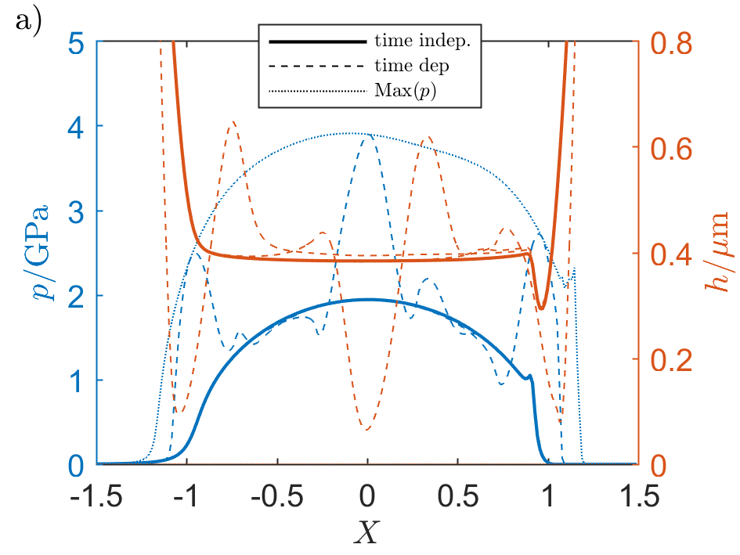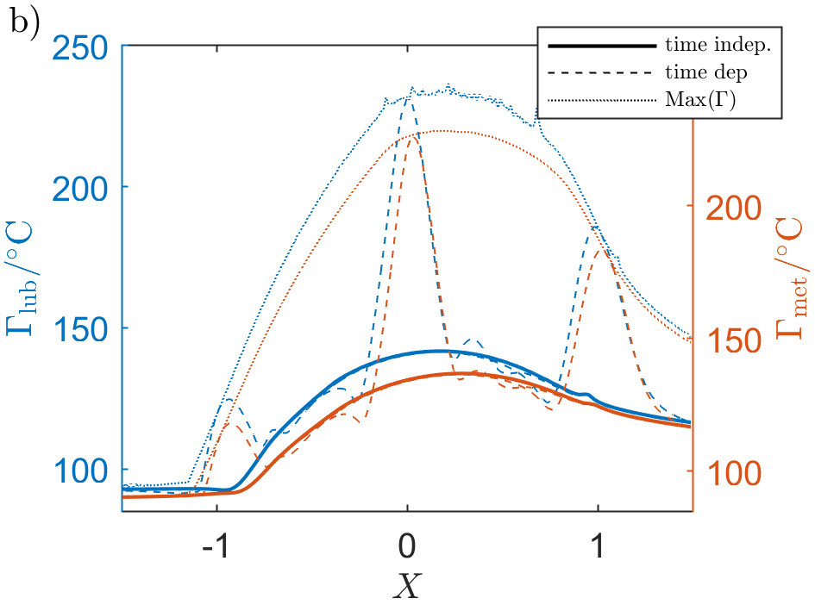

Fig. 4. Results of a single asperity in a rolling siding contact. a) Pressure and film thickness and b) the temperature fields in the lubricant and the asperity surface.

* 1. Point asperity causing metal contact in a sliding line contact

This section presents the input files to use in order to replicate previous results of a single asperity which breaks through the lubricant and thus causes metal contact. The results could be validated against the results in the literature [7]. The input parameters are presented in Table 6. The results generate are presented in Fig. 5. Contour plots are presented in Fig. 5c and Fig. 5d to show the full results for the time dependent case when the asperity was at *X* = 0.

Table 6. Input values for simulating a single asperity causing metal contact in a rolling sliding contact

|  |  |  |  |  |  |  |  |
| --- | --- | --- | --- | --- | --- | --- | --- |
| **meth** | **Tmeth** | **Geom** | **Aspchape** | **Contact alg** | **p_ave_param** | **shift_y** | **Multi_grid_param** |
| 2 | 4 | 1 | 12 | 1 | 1 | 35 | 1 |
|  |  |  |  |  |  |  |  |
| **NX,** | **NY,** | **X0,** | **XE,** | **F Grid** | **DZ_method** | **Dw_meth** | |
| 265 | 100 | -2 | 1.5 | 0.5 | 1 | 1 | 1 |
|  |  |  |  |  |  |  |  |
| **RX,** | **W0*(E5 if Cylinder)** | **Ua,** | **Ub,** | **lub_param** | **Shear_thin** | **temp** | **solid_mat** |
| 0.0106 | 11.0 | 8 | 9 | 4 | 0 | 1 | 1 |
|  |  |  |  |  |  |  |  |
| **B/B_ref/PH_new*1e9** | **by/-/-** | **Ph*1e9/=/=** | **Ry** |  |  |  |  |
| 0.0068 | 10.775 | 7 | 7 |  |  |  |  |
|  |  |  |  |  |  |  |  |
| **Asph_real [um]** | **aspw_real [um]** | **Asph_real2 [um]** | **aspw_real2 [um]** | **Asp_ratio W_X/W_Y** | **Hminimum*1E-6 [-]** | **surf_scale** | |
| 3 | 200 | 1.5 | 100 | 1 | 80 | 1.5 |  |
|  |  |  |  |  |  |  |  |
| **Elast1 [GPa]** | **Elast2 [GPa]** | **EE [GPa]** |  |  |  |  |  |
| 206 | 206 | 0 | <- If zero, read E1 and E2 | | |  |  |
|  |  |  |  |  |  |  |  |
| **MK_stat** | **MK_time** | **ER_stat** | **ER_time** | **KK** | **KK_time** |  |  |
| 400 | 300 | 0.1 | 0.1 | 10 | 10 |  |  |
|  |  |  |  |  |  |  |  |
| **C_meth** | **C_loc** | **C_glob** | **C_min** | **C_max** | **umax_P** |  |  |
| 8 | 0.1 | 0.05 | 0.05 | 0.5 | 1 |  |  |
|  |  |  |  |  |  |  |  |
| **H00,** | **HM0f** |  |  |  |  |  |  |
| -1.5 | 0.5 | 0 | 130 |  |  |  |  |
|  |  |  |  |  |  |  |  |
| **Temp=Ta degC** | **Z** | **EDA0** | **Pref *1e8** | **alpha*1E-8** | **RA1*1E-9** | **RA2*1E-9** |  |
| 90 | 0.68 | 0.04 | 1.98 | 2.17 | 0.69 | 2.55 |  |
|  |  |  |  |  |  |  |  |
| **kH*1E-6** | **xH*1E-9** | **lH*1E-9** | **gH*1E-9** |  |  |  |  |
| 63.15 | 5.1 | 1.68 | 2.266 |  |  |  |  |
|  |  |  |  |  |  |  |  |
| **EpsT0** | **S0** | **RL_G0** | **Dz** | **Cz** |  |  |  |
| 0.00068 | 1.25 | 4.57 | 0.5 | -0.071 |  |  |  |
|  |  |  |  |  |  |  |  |
| **Tg0,** | **YA1,** | **YA2,** | **YB1,** | **YB2on** |  |  |  |
| 2 | 0 | 0 | 0 | 10 | 0.075 | 5 |  |
|  |  |  |  |  |  |  |  |
| **YC1,** | **YC2,** | **Yedag,** | **Yalfag,** |  |  |  |  |
| 16.01 | 20.69 | 1 | 3.814697 |  |  |  |  |
|  |  |  |  |  |  |  |  |
| **tauc_real,** | **tauS,** | **taua2,** | **xilim** | **xi_param** |  |  |  |
| 25 | 0.4 | 0 | 0.8 | 1 |  |  |  |
|  |  |  |  |  |  |  |  |
| **L_n** | **L_G*1e4** | **L_h_limit*1e-9 [m]** | **L_iter** | **L_stab** | **shear max** | **shear min** | **temp max** |
| 0.74 | 3.1 | 1 | 20 | 1 |  |  |  |
|  |  |  |  |  |  |  |  |
| **collect_full_data** | **single_step_only** | **selected_step** | |  |  |  |  |
| .false. | .false. | 423 |  |  |  |  |  |
|  |  |  |  |  |  |  |  |
| **use_multiple_cores** | **cores** |  |  |  |  |  |  |
| .true. | 8 |  |  |  |  |  |  |

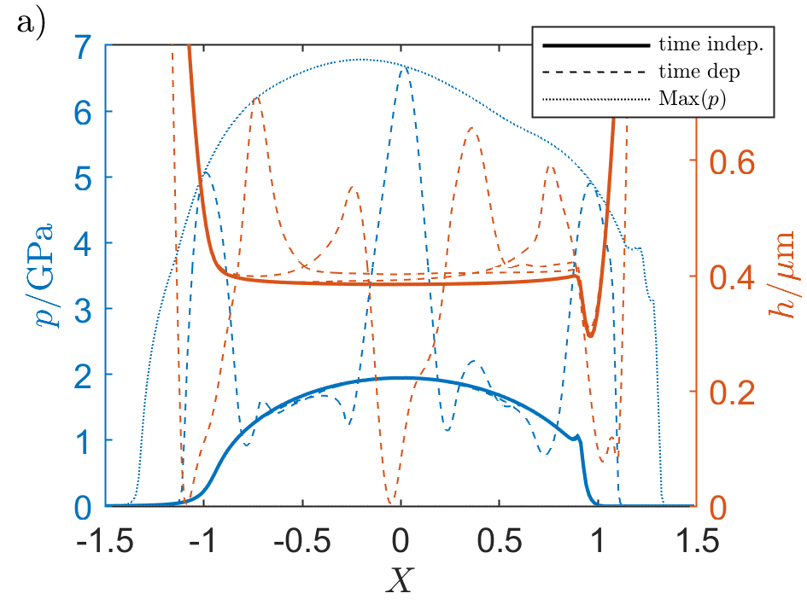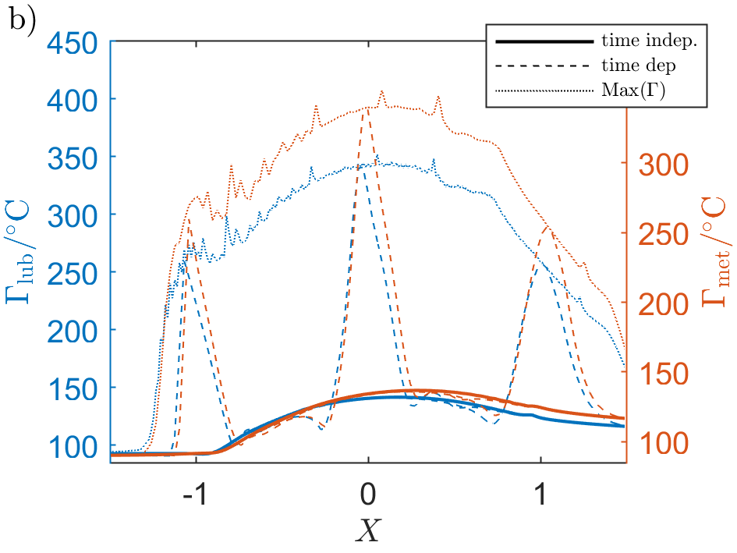

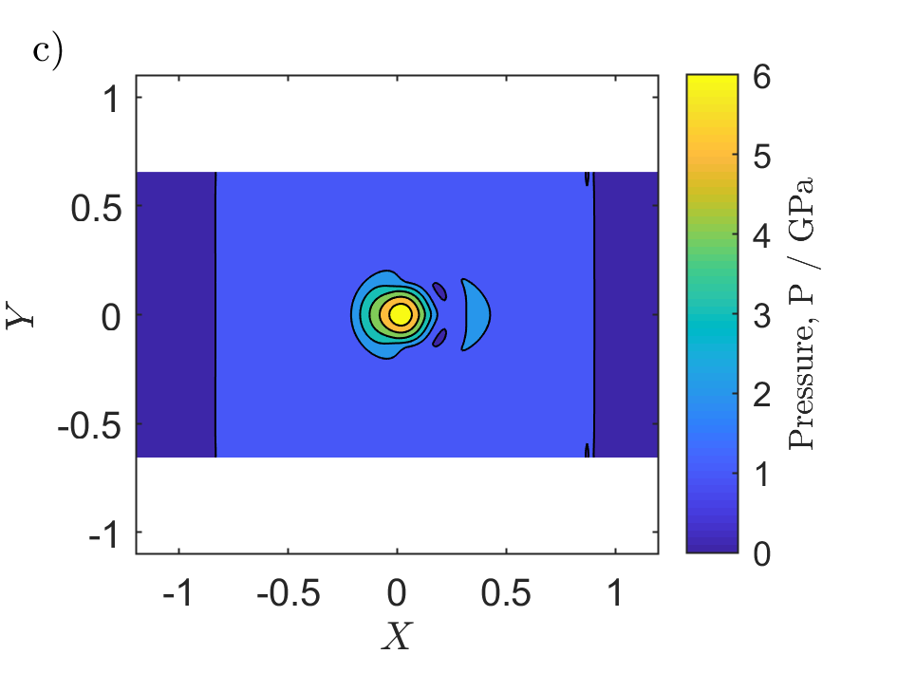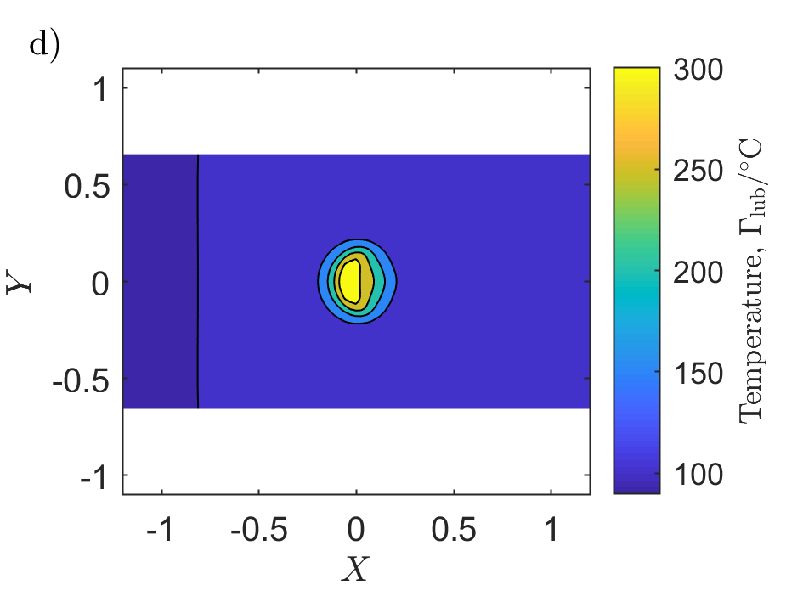

Fig. 5. Results of a single asperity causing metal contact in a rolling siding contact. a) Pressure and film thickness and b) the temperature fields in the lubricant and the asperity surface at the centre line. The contour plots in c) and d) shows the results when the asperity was at X=0.0.

* 1. Shot peened surface in a sliding line contact.

This section presents the input file to use in order to replicate the simulations of the shot peened surface as it passes through a TEHL contact with a slide to roll ratio of -12%. The simulations needs a csv file containing the shapes of the surfaces roughness. The shot peened surface used in the main article is included with the supplementary material. The results could be validated against Fig. 8 in the main article. The input parameters are presented in Table 7. The results generate are presented in Fig. 6a and 6b. The figure in Fig. 6c is included to show the transverse aspects of the solution as the roughness enters the contact area.

Table 7. Input values for simulating a rough surface causing metal contact in a rolling sliding contact

|  |  |  |  |  |  |  |  |
| --- | --- | --- | --- | --- | --- | --- | --- |
| meth | Tmeth | Geom | Aspchape | Contact alg | p_ave_param | shift_y | Multi_grid_param |
| 2 | 4 | 1 | 200 | 1 | 1 | 3 | 1 |
|  |  |  |  |  |  |  |  |
| NX, | NY, | X0, | XE, | F Grid | DZ_method | Dw_meth | |
| 265 | 164 | -2 | 1.5 | 1 | 1 | 1 | 1 |
|  |  |  |  |  |  |  |  |
| RX, | W0*(E5 if Cylinder) | Ua, | Ub, | lub_param | Shear_thin | temp | solid_mat |
| 0.0106 | 11.0 | 8 | 9 | 4 | 0 | 1 | 1 |
|  |  |  |  |  |  |  |  |
| B/B_ref/PH_new*1e9 | by/-/- | Ph*1e9/=/= | Ry |  |  |  |  |
| 0.0068 | 10.775 | 7 | 7 |  |  |  |  |
|  |  |  |  |  |  |  |  |
| Asph_real [um] | aspw_real [um] | Asph_real2 [um] | aspw_real2 [um] | Asp_ratio W_X/W_Y | Hminimum*1E-6 [-] | surf_scale | |
| 1.5 | 200 | 1.5 | 100 | 1 | 5 | 1.5 |  |
|  |  |  |  |  |  |  |  |
| Elast1 [GPa] | Elast2 [GPa] | EE [GPa] |  |  |  |  |  |
| 206 | 206 | 0 | <- If zero, read E1 and E2 | | |  |  |
|  |  |  |  |  |  |  |  |
| MK_stat | MK_time | ER_stat | ER_time | KK | KK_time |  |  |
| 400 | 50 | 0.8 | 1 | 5 | 5 |  |  |
|  |  |  |  |  |  |  |  |
|  | C_meth | C_loc | C_glob | C_min | C_max | umax_P |  |
| 7 | 0.1 | 0.05 | 0.05 | 0.5 | 1 |  |  |
|  |  |  |  |  |  |  |  |
| H00, | HM0f |  |  |  |  |  |  |
| -1.5 | 0.5 | 0 | 130 |  |  |  |  |
|  |  |  |  |  |  |  |  |
| Temp=Ta degC | Z | EDA0 | Pref *1e8 | alpha*1E-8 | RA1*1E-9 | RA2*1E-9 |  |
| 90 | 0.68 | 0.04 | 1.98 | 2.17 | 0.69 | 2.55 |  |
|  |  |  |  |  |  |  |  |
| kH*1E-6 | xH*1E-9 | lH*1E-9 | gH*1E-9 |  |  |  |  |
| 63.15 | 5.1 | 1.68 | 2.266 |  |  |  |  |
|  |  |  |  |  |  |  |  |
| EpsT0 | S0 | RL_G0 | Dz | Cz |  |  |  |
| 0.00068 | 1.25 | 4.57 | 0.5 | -0.071 |  |  |  |
|  |  |  |  |  |  |  |  |
| Tg0, | YA1, | YA2, | YB1, | YB2on |  |  |  |
| 2 | 0 | 0 | 0 | 10 | 0.075 | 5 |  |
|  |  |  |  |  |  |  |  |
| YC1, | YC2, | Yedag, | Yalfag, |  |  |  |  |
| 16.01 | 20.69 | 1 | 3.814697 |  |  |  |  |
|  |  |  |  |  |  |  |  |
| tauc_real, | tauS, | taua2, | xilim | xi_param |  |  |  |
| 25 | 0.4 | 0 | 0.8 | 1 |  |  |  |
|  |  |  |  |  |  |  |  |
| L_n | L_G*1e4 | L_h_limit*1e-9 [m] | L_iter | L_stab | shear max | shear min | temp max |
| 0.74 | 3.1 | 1 | 20 | 1 |  |  |  |
|  |  |  |  |  |  |  |  |
| collect_full_data | single_step_only | selected_step | |  |  |  |  |
| .false. | .false. | 423 |  |  |  |  |  |
|  |  |  |  |  |  |  |  |
| use_multiple_cores | cores |  |  |  |  |  |  |
| .true. | 8 |  |  |  |  |  |  |

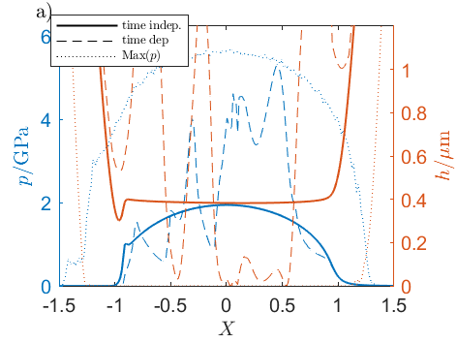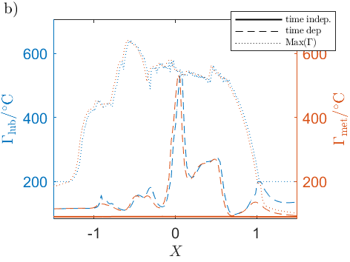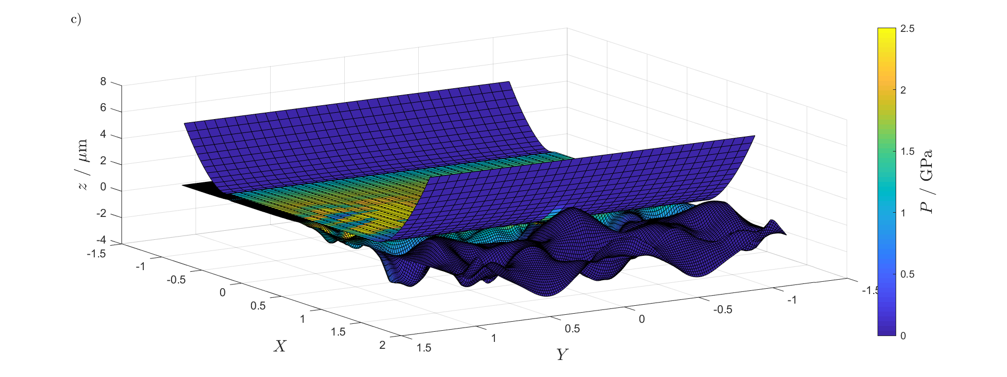

Fig. 6. Results of shot peened surface causing metal contact in a rolling siding contact. a) Pressure and film thickness and b) the temperature fields in the lubricant and the metal surface at the centre line. c) Graphical illustration of the transverse aspects of the solutions.

# References

|  |  |
| --- | --- |
| [1] | P. Huang, Numerical calculations of lubrication: methods and programs, Guangzhou, China: John Wiley & Sons, 2013. |
| [2] | K.L. Johnson, Contact mechanics, Cambridge University Press, 2003, pp. 242-283. |
| [3] | S. Liu, Q. Wang, G. Liu, ”A versatile method of discrete convolution and FFT (DC-FFT) for contact analyses,” *Wear,* vol. 243, pp. 101-111, 2000. |
| [4] | C.H. Venner, A.A. Lubrecht, ”Transient Analysis of Surface Features in an EHL Line Contact in the Case of Sliding,” *ASME. J. Tribol.,* vol. 116, 1994. |
| [5] | M.J.A. Holmes, H.P. Evans, T.G. Hughes, R.W. Snidle, ”Transient elastohydrodynamic point contact analysis using a new coupled differential de¯ection method Part 1: theory and validation,” *Proceedings of the Institution of Mechanical Engineers, Part J: Journal of Engineering Tribology,* vol. 217, nr 4, p. 289–304, 2003. |
| [6] | C.H. Venner, A.A. Lubrecht, ”Numerical Simulation of a Transverse Ridge in a Circular EHL Contact Under Rollin/Sliding,” *Journal of Tribology,* vol. 116, pp. 751-761, 1994. |
| [7] | C.-M. Everitt, B. Alfredsson, ”Surface initiation of rolling contact fatigue at asperities considering slip, shear limit and thermal elastohydrodynamic lubrication,” *Tribology International,* vol. 137, pp. 76-93, 2019. |